**Chapter One: Introduction and Background**

The dental clinic is one of the important parts of our life. All of people have to go to the dental clinic when they get some problem with their teeth such as toothache, gum ache or teeth braces. It is like when we go to the hospital, but for the dental clinic it treats only problems with the teeth. In one, a clinic has many patients and many cases for treating. One of the common cases, for example, is the teeth braces which often require a long term treatment, possibly up to 4 years. The patient who has teeth braces has to make an appointment with the dentist around once a month.

The problem is patients often lose their appointment card and forget the appointment date, which may affect their health. They will have some trouble with their teeth, which sometimes can be very dangerous. In some cases, patients want to change their appointment date. They do not know exactly when the dentist is free because the dentist has his/her own schedule which contains all of the patient appointments. Besides the problems with appointments, patients may also want to know the total cost of their case.

To solve these problems, “The dental clinic website and mobile application” provides functions for patients, visitors, officers and dentists. For visitors who are interested in dental treatments, the website and mobile application provides information about dental treatment and estimated cost. Visitors can also interact with the dentist on the web. Visitors can consult with the dentist about some problem they are experiencing. This website and mobile application includes dentists schedule and also the appointment feature which allows visitors to make an appointment with a dentist online. For patients, the website and mobile application contains the reminder function for reminding them of upcoming appointments so that they do not miss the appointments. The same feature also sends out a notification when the schedule changes. It will notify about the appointment 1-2 days before the appointment date. The dental clinic website and application can also generate the QR code for each patient, which can be used to identify the patient and his/herappointment at the clinic. This streamlines the process of receiving patients and looking up appointments. At the same time, it relieves the problems of patients losing or forgetting to bring their appointment cards.

.

**Chapter Two: Literature Review**

**2.1 Business review**

**2.1.1 Dental Clinic Website and Mobile application**

Dental Clinic Website and Mobile application is a systemthat provides services to customers of Dental Clinic(patient) such as dentist's schedule, managing appointments and reminders, promotions, dental's information, consulting and follow up betweena dentist and a patient. Customers can access both the web application and the mobile application that Officer insert into the website. Dentists can have an interaction with customers through both applications, by giving consultation and following up their patients.

Examples of dental website and mobile application are shown below.

**2.1.1.1 Dental Clinic by Cosmetic Innovations, Inc**.

Dental Clinic is a patient’s guide to understanding all aspects of dentistry and its procedures. This application includes the most frequently asked dental questions answered by the top dental experts in each field, and overseen by NYC Cosmetic & General Dentist - Dr. Marc Lazare. This app includes:

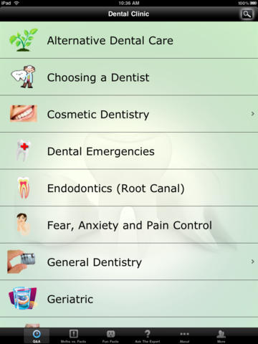

Figure 1: Show all menu that customer can use.

As shown in Figure 1, when user open the application user can see all of these menu items that user can select to see information.

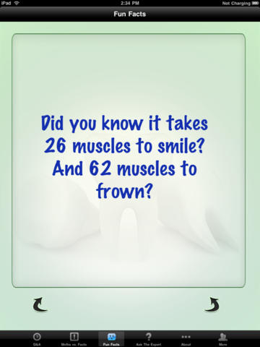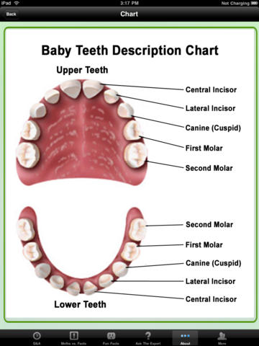

Figure 2: Show user interface after user select some menu

As shown in Figure 2, users can select to see the useful information such as ‘Best ways to minimize your pain, fear and anxiety’ • ‘All of the important information you should know about your children’s dental care’ • ‘Knowing what all of your options are when missing one or more teeth’ • ‘What you should know about teeth whitening’.

### 2.1.1.2 Dr.Sunil Dental Clini - Cosmetic, Oral & Implant Dentistry

The website for Dental Center in Bangkok which provides foreign customers with advertisement of the clinic including the information about the services provided to customers. Customers can fill the document form to make an appointment. Customers also can use the provided QR code to call, email, and visit the website of dental clinic. But this website is only for customers and has only some information of dental care. Dentists cannot interact with customers directly.

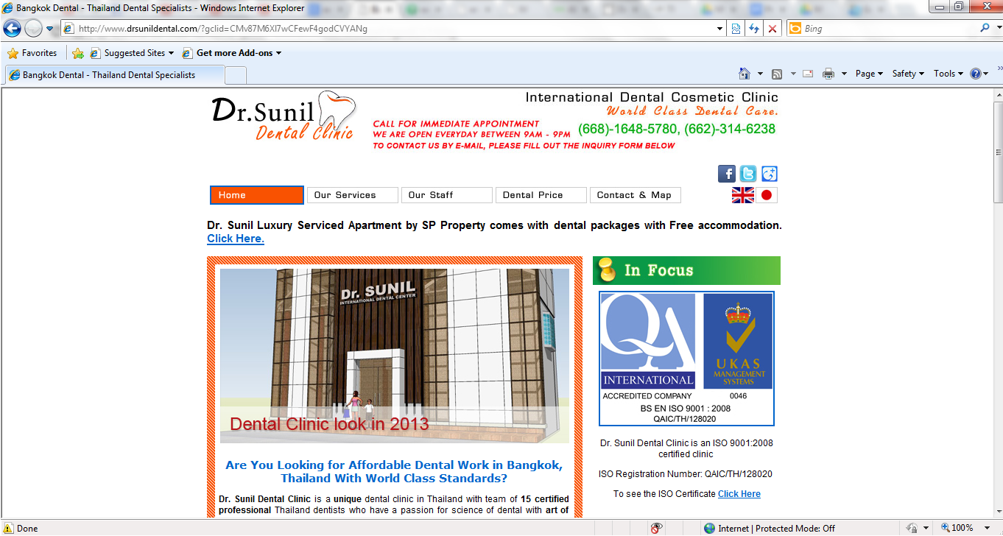

### 

Figure 3: Show website of Dr.Sunil Dental Center

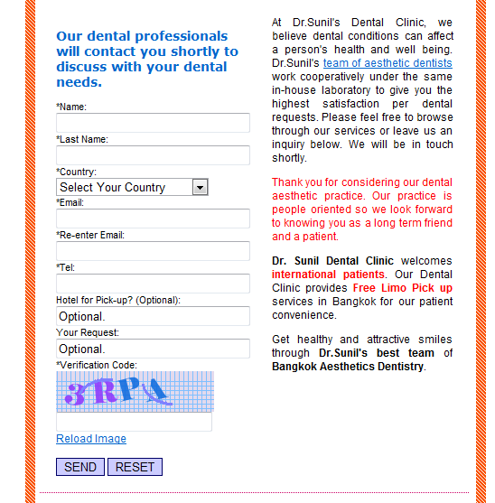

Figure 4: Show the contact with Dr. Sunil

As shown in Figure 4, Customer can send their information to Dr. Sunil and wait for email and might get an appointment.

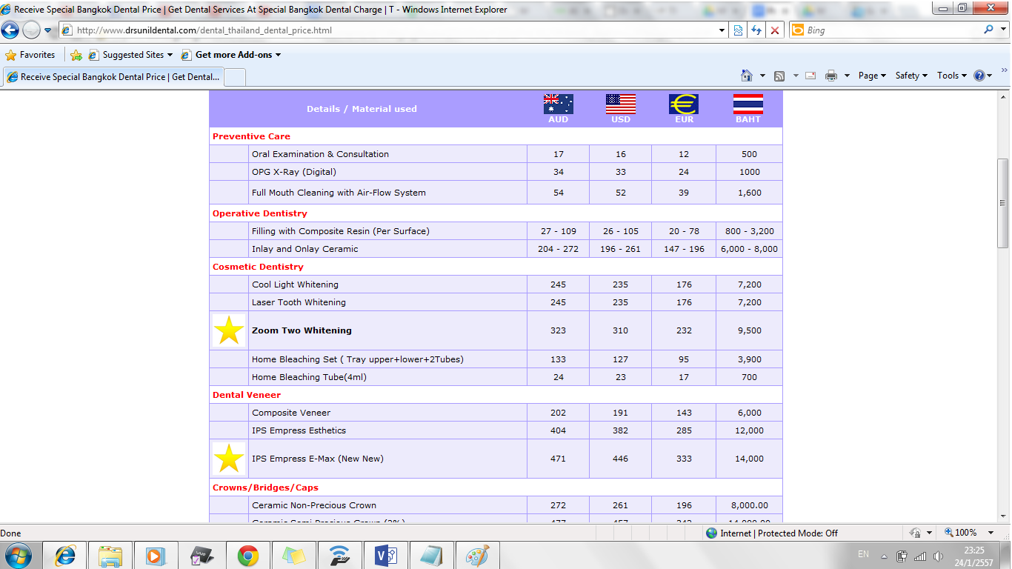

Figure 5: Show the price rate

As shown in Figure 4, Customer can see the cost that they have to pay for each treatment.

**2.2 Technology Review**

**2.2.1 QR code**

**2.2.1.1 QR code**

QR code (quick response code) is a type of [2D barcode](http://searchmobilecomputing.techtarget.com/definition/2D-barcode) that is used to provide easy access to information through a [smartphone](http://searchmobilecomputing.techtarget.com/definition/smartphone).

In this process, known as mobile tagging, the smartphone’s owner points the phone at a QR code and opens a [barcode reader](http://whatis.techtarget.com/definition/barcode-reader-POS-scanner-bar-code-reader-price-scanner) app which works in conjunction with the phone’s camera. The reader interprets the code, which typically contains a call to action such as an invitation to download a mobile application, a link to view a video or an [SMS](http://searchmobilecomputing.techtarget.com/definition/Short-Message-Service) message inviting the viewer to respond to a poll. The phone’s owner can choose to act upon the call to action or click cancel and ignore the invitation. The QR code can recognize the URL website. Normally the URL website is difficult to keep because it’s too long and some of it is too complex. For QR code just scanning an item with a QR code provides a link tothe website of that item.[1] **API QR Codes**

An application programming interface (API) which allows users to send requests to create QR codes and returns the image of the QR code (in .png). Requests are made using simple HTML requests and, if successful, return raw image data. [jquery.qrcode.js](http://jeromeetienne.github.com/jquery-qrcode) is a *jquery plugin for a pure browser QR code generation*. It allows you to easily add qrcode to your webpages. It’s enables you to dynamically add QR codes to your website. [2]

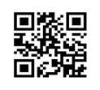

**2.2.1.2 Alternative Technology**

QR code is quite similar to 2D barcode and RFID (Radio-frequency identification). Both of them contain information and can replace QR code. A barcode is normally used more than QR code and RFID especially because it cheaper than the others. Finally they can store information in the platform like a symbol and reliable.

**2.2.1.3 The selection of this technology**

The reason why we choose QR code technology is because it is now very popular and most people use a smartphone. It is easy to use and comfortable. -Using a QR code for identification, patients do not need to bring their appoint card when they come to the clinic. And another reason for using QR code is that is it faster and more reliable than using appointment cards. Patients can use the QR code only in the smartphone that has a program support the QR code application. We use the JavaScript QR code because it is the web application so, the JavaScript QR code as a plug in for the web browser.

**2.2.2 Phone GAP**

**2.2.2.1 Phone GAP**

[PhoneGap](http://www.phonegap.com) is an application framework that enables you to build natively installed applications using HTML and JavaScript. The easiest way to think of PhoneGap is a web view container that is 100% width and 100% height, with a JavaScript programming interface that allows you to access underlying operating system features. You build your user interface using traditional web development skills (HTML, CSS, & JavaScript), and use the PhoneGap container to deploy to different application ecosystems and devices. When packaged for deployment, the PhoneGap application is a binary distributable file that can be distributed by the “normal” application marketplaces (iTunes, Google App Market, Amazon Market, etc…)

PhoneGap can be used to build applications that target multiple platforms, including Apple iOS, Google Android, Windows Phone, BlackBerry, HP WebOS, Symbian, and Bada.[3]

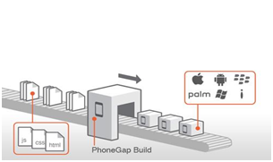

**2.2.2.2 Alternative Technology**

Xcode and Titanium are integrated development environments (IDEs) that help create mobile applications which can be used on smartphones and tablets. Xcode includes a suite of development tools to build iOS mobile applications directly, while Titanium can create applications for many platforms, similarly to PhoneGap. It supports iOS, Android, and etc. The programming languages supported are JavaScript, HTML, CSS, Phython, Ruby, and PHP.

**2.2.2.3 The selection of this technology**

For choosing PhoneGap to develop the application because this kind of technology is flexible, convenient and it is an open source. We will create the mobile application by useing html5, css, and javascript, all of which are supported by PhoneGap. And it can support 7 kinds of operating systems including iOS which is the mobile platform we have chosen for this project.. PhoneGap will wrap the website to be the application. It contains the features that we have to use for this project such as camera function or database.

**2.2.3 HTML5**

**2.2.3.1 HTML5**

## HTML5 is markup language used for createing websites. Evolved from the HTML standard, HTML5 has more features such as working with MAP system, and creating a graphic without flash. And HTML5 is supported by many operating systems on various devices such as Windows PC, MAC, iPhone, iPad, and Android-based mobile phones andtablets. It works with CSS and JavaScript and can be used not only to develop for the world wide web also but also to create mobile applications.



**2.2.3.2 Alternative Technology**

-

**2.2.3.3 The selection of this technology**

HTML5 has been selected for this project because it is the newest version of the HTML and supported by PhoneGap along with CSS and JavaScript. It can be used to develop both the dental clinic website and the mobile application of dental clinic.

**2.2.4 SQLite**

**2.2.4.1 SQLite**

## SQLite is an in-process library that implements a [self-contained](http://www.sqlite.org/selfcontained.html), [serverless](http://www.sqlite.org/serverless.html), [zero-configuration](http://www.sqlite.org/zeroconf.html), [transactional](http://www.sqlite.org/transactional.html) SQL database engine. The code for SQLite is in the [public domain](http://www.sqlite.org/copyright.html) and is thus free for use for any purpose, commercial or private. SQLite is currently found in more applications than we can count, including several [high-profile projects.[4]](http://www.sqlite.org/famous.html)



**2.2.4.2 Alternative Technology**

MySQL is a database, a structured collection of data. It may be anything from a simple shopping list to a picture gallery or the vast amounts of information in a corporate network. To add, access, and process data stored in a computer database, you need a database management system such as MySQL Server. Since computers are very good at handling large amounts of data, database management systems play a central role in computing,as standalone utilities, or as parts of other applications.[5]



**2.2.4.3 The selection of this technology**

The dental clinic system needs to store and maintain patients information as well as the information of treatments and others. All data need to be stored in a database that enables secure and stable management of the information

**Chapter Three : Quality Standard**

**3.1 ISO29110 for Very Small Entity(VSE)**

ISO29110 is a guide applies to a Very Small Entity (SVE), enterprise, organisation, department or project up to 25 people, dedicate to software development. The Guide provides Project Management and Software Implementation process which integrate practices based on the selection of ISO/IEC 12207- System and Software Engineering - Software Life Cycle Processes and ISO/IEC 15289 Software Engineering - Software Life Cycle Process - guidelines for the content of software life cycle process information products(documentation) standard elements.

**3.1.1 Project Management Process**

The propose of the Project Management process is to establish and carry out in a systematic way the task of the software implementation project, which allows complying with the project’s objectives in the expected quality, time and cost.

**Selected process**

3.1.1.1 Project Planing Process

3.1.1.2 Project Plan Excution Process

3.1.1.3 Project Plan Assesment and Control Process

3.1.1.4 Project Closer Process

**3.1.2 Software Implementation process**

The purpose of the Software Implementation process is the systematic performance of the analysis, design, construction, integration and tests activities for new or modified software products according to the specified requirements.

**Selected process**

3.1.2.1 Software Implementation Initiation Process

3.1.2.2 Software Requirements Analysis Process

3.1.2.3 Software Architectural Design Process

3.1.2.4 Software Construction Process

3.1.2.5 Software Integration and Test Process

3.1.2.6 Software Delivery Process

**Chapter Four : Project Plan**

**4.1 Motivation**

Nowadays people in Thailand are more interested in dental care, and the number of dental clinics is increasing very fast, each with different number of patients. Dental clinics needto handle many patients and also many problems. Some of the typical examples are; patients forget about their appointment, patients do not have any knowledge about dental care, patients do not know the dentist schedule. Systems dedicated to serving dental care providers and patients will help solve these problems.

According to a recent research about mobile phone use, the number of smartphone users in 2013 increased by 29.1 percent from 2012 and the number of people using mobile internet increased by 32 percent in 2013. People always use their phone to do many things such as entertainment, booking, shopping, communicating with others, accounting, and marketing. IOS is one of the major operating systems for mobile devices, for dental clinic using IOS is more suitable because apple company need to approve the application first, so it’s guarantee that the application is approved by high quality company. For the user who not use IOS or smartphone another way that the user can keep contact is using the internet through browser.

In addition, such systems for dental clinics may improve the quality of services provided to their patients. For instance, most dental clinics rely on appointment cards to receive patients and keep track of their appointments. When patients arrive at the dental clinic, they have to provide their appointment card at the reception desk and the officer would have to look up the patient chart, which usually takes time. By integrating smartphones and QR codes into the workflow, our system can identify appointments faster and reduce the work of officer. For the dental clinic, QR codes is more suitable than barcodes because QR codes can be stored in and read from smartphones as well as traditional paper-based cards.

**4.2 Aim and Objective**

The aim of this project is to develop a website and a mobile application that can help patients make appointments with dentists more easily and manage their appointments more efficiently. The system should support the management of the appointment schedule for both dentists and patients, remind patients about an upcoming appointment, provide dentists’ schedule to the visitors who want to make an appointment, reduce the time and work of dental clinic officers. The system will make sure that each patient has an appointment, gets proper consult from a dentist and also provide useful knowledge about dental treatment and dental care.

Objectives

1. To develop a web application and a mobile application which

1.1 Facilitate patients to make an appointment.

1.2 Facilitate patients to receive an appointment.

1.3 Facilitate patients to receive the reminder of the upcoming appointment.

1.4 Facilitate patients to find dentists’ availability for making a new appointment.

1.5 Facilitate patients to change the time to meet the dentist

1.6 Facilitate patients to ask for an advice from a dentist when he/she has a dental problem.

1.7 Facilitate visitors to estimate the cost of treatment programs.

1.8 Facilitate patients who has a smart phone to use the QR code instead of the appointment card.

1.9 Facilitate patients and visitors to see the information and advertisement about the dental clinic

2. To implement the web services which support the mobile application and web application described in 1

**4.3 Architecture**

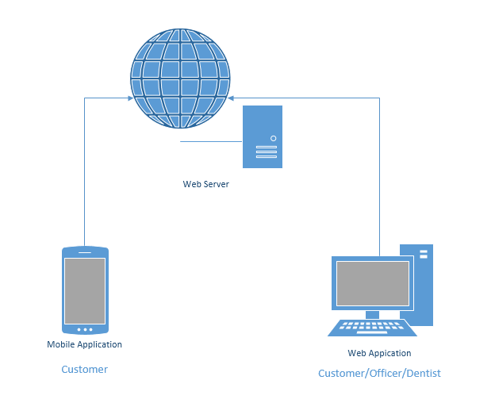

**4.4 Deliverables and Limits**

**4.4.1 Deliverables**

The dental clinic application, the final product will consist of

**Software system**

**1. Web application**

The dental web application is a website that supports dental clinics with which have many patients. To solve the patientss problems discussed in , the website provides the following functionalities to the patients and visitors of the dental clinic w:

- Making an appointment when the patient wants to change their appointment date

- Finding the dentist’s available time to make an appointment

- Receiving the appointment from the dental clinic server

- Receiving the reminder of the appointment

- Receiving the details of appointment as a QRcode

- Getting an advice from the dentist about dental problems

- Viewing information about dental problems, treatments and advertisements

- Viewing the dentist’s schedule day by day

- Estimating the cost of treatment programs

**2. Mobile application**

The dental mobile application is an application for smartphones on the IOS operating system that supports dental clinics which have many patients. To solve the patient’s problems discussed in so, the mobile application supports the patients and visitors to perform the following tasks:

- Making an appointment when the patient wants to change their appointment date

- Finding the dentist’s available time to make an appointment

- Receiving the appointment from the dental clinic server

- Receiving the reminder of the appointment

- Receiving the details of appointment as a QRcode

- Identifying the patient and his/her appointment using a QR code

- Getting an advice from the dentist about dental problems

- Viewing information about dental problems, treatments and advertisements

- Viewing the dentist’s schedule day by day

- Estimating the cost of treatment programs

**3. Web service**

The web service that supports the followings:

- Sending appointment information

- Generating the appointment information to become QR code

- Authentication and authorization

- File hosting

**Documentation**

- -

• Project Proposal

• Project Plan

• Software Requirement Specification

• Software Design Document

• Testing Documents

-- Test Plan

-- Unit Test Document

-- System Test Document

• Traceability Record

**4.4.2 Limits**

- Web application can run on Internet explorer, Mozilla firefox, and google chrome only.

- Mobile devices (smartphones) should use the operating system iPhone 7.0 or newer versions.

- Mobile devices (smartphones) should support Edge, Wifi and 3G.

- Internet connection is required.

Without Internet Access, user can receive the message from clinic.

*(message contain the appointment information)

**4.5 Future work**

- Available on every operating system platform

- Use other technologies to make a comfortable to user such as RFID,

**4.6 Schedule and Milestone**

This section presents the schedule and milestones that cover all the activities to be undertaken in the project. According to the current plan, the project will be completed by September, 2014. and a detail work plan with the details of each activity listed below will be prepared at the beginning of the project.

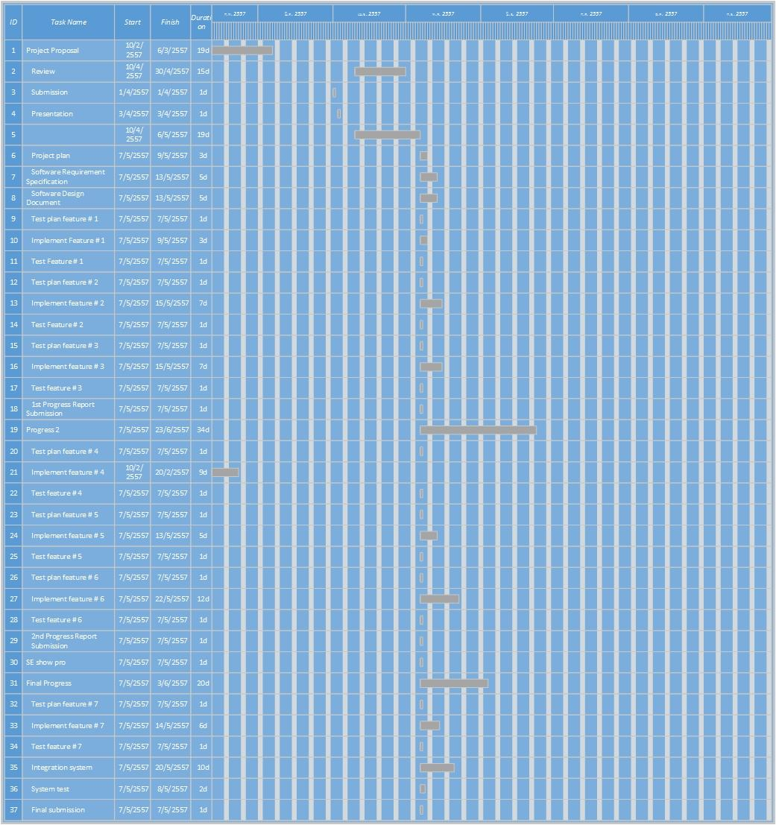**Chapter five : References**

[1] <http://searchengineland.com/what-is-a-qr-code-and-why-do-you-need-one-27588>

[2] <http://larsjung.de/qrcode/>

[3] <http://phonegap.com/about/features>

[4] http://[sqlite.org/‎](http://www.sqlite.org/famous.html)

[5] <http://dev.mysql.com/doc/refman/4.1/en/what-is-mysql.html>

[6] <http://www.atimedesign.com/webdesign/%E0%B8%A7%E0%B8%87%E0%B8%81%E0%B8%B2%E0%B8%A3%E0%B8%AA%E0%B8%A1%E0%B8%B2%E0%B8%A3%E0%B9%8C%E0%B8%97%E0%B9%82%E0%B8%9F%E0%B8%99%E0%B9%84%E0%B8%97%E0%B8%A2%E0%B8%81%E0%B8%B1%E0%B8%9A%E0%B9%80%E0%B8%A7/>

[7] <http://thumbsup.in.th/2013/04/increase-mobile-users-push-web-responsive-design/>